Note instruction for install mongodb on windows:

Using this command to run mongo bd:

C:\mongodb\bin\mongod.exe --dbpath d:\test\mongodb\data

C:\>d:\mongo_db\bin\mongod.exe --dbpath d:\mongo_db\data

http://stackoverflow.com/questions/4502531/creating-a-database-in-mongo-cant-connect-get-connect-failed

Conncect

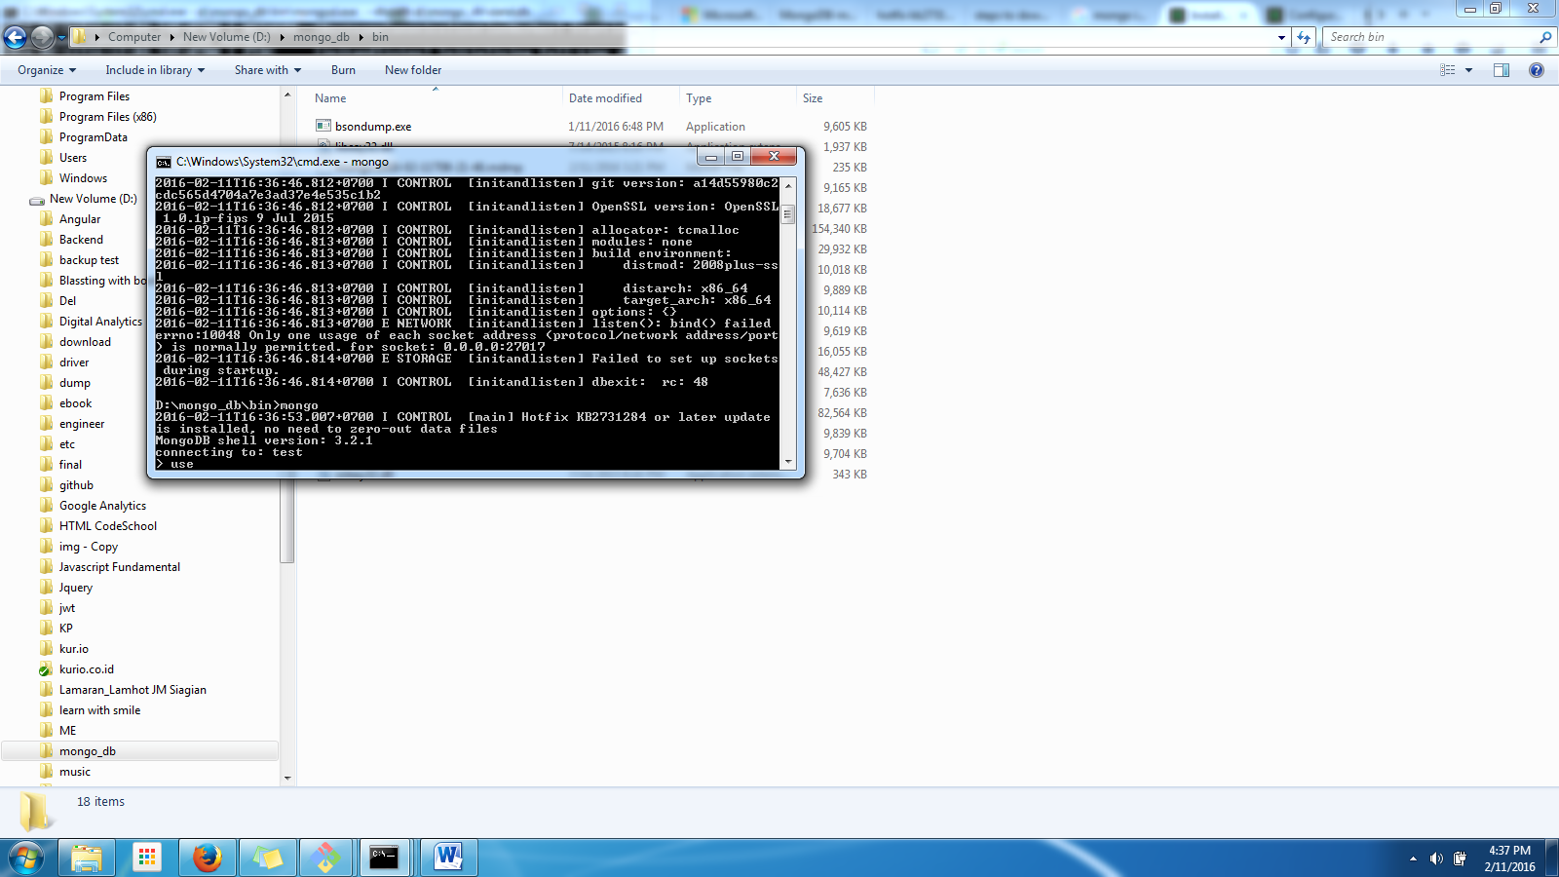

Install Express JS

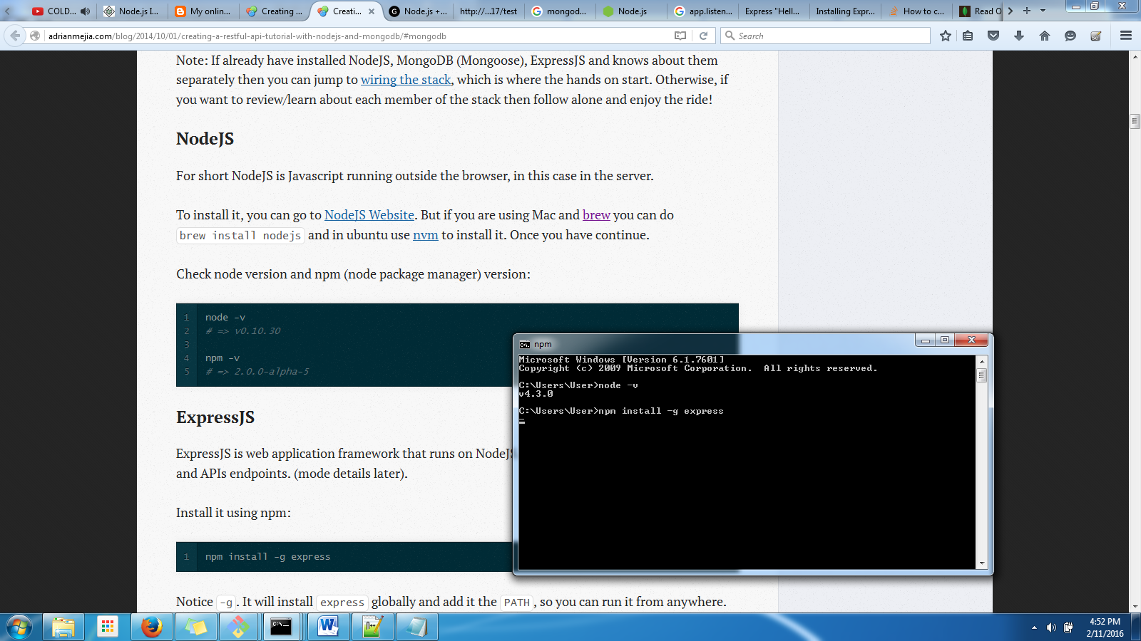

Create new project with express.js

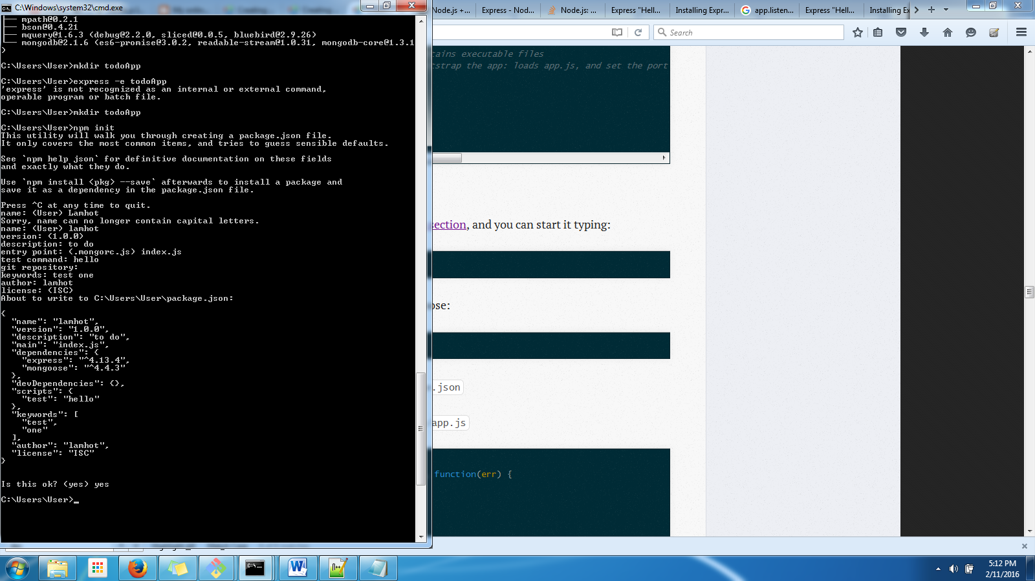

npm install mongoose --save

Code IS IMPORTANT

npm install -g express-generator.

How we can connect to mongo db

* D:\mongo_db\bin>mongod --dbpath c:\users\user\todoApp\data\

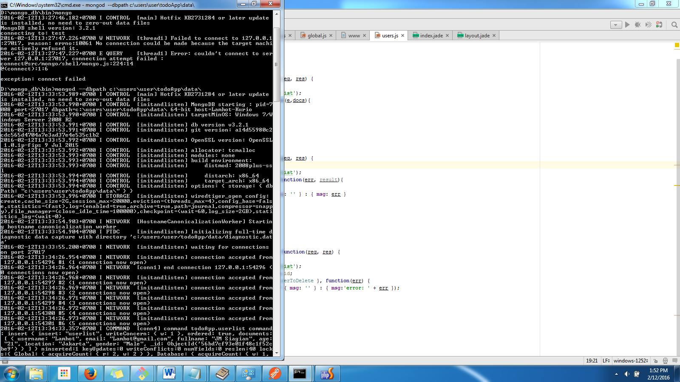

This keynote is so very important to install web rest : with nodeJs

1. <http://cwbuecheler.com/web/tutorials/2014/restful-web-app-node-express-mongodb/>
2. <http://adrianmejia.com/blog/2014/09/28/angularjs-tutorial-for-beginners-with-nodejs-expressjs-and-mongodb/>

// this command is important to generate epress js on project

C:\Users\User>express e simpleRest

This is command for testing:

Node ./node_modules/mocha/bin/_mocha

Doing first mongod.exe at folder:

